Cross-Attentive Wavelet-Transformer (CAWT) for ECG Arrhythmia Detection
Submitted in partial fulfilment for the award of the degree in
BACHELOR OF TECHNOLOGY
In
ELECTRONICS AND COMMUNICATION ENGINEERING
Submitted by
M. P. Hari Chandra Hlada (22331A04A8)
K. Varshini (22331A0484)
L.P. Harshita (22331A0496)
K. Raj Samuel (22331A0485)
Under the guidance of
Dr. M. Lakshmi Prasanna Rani, M. Tech, Ph.D.

Associate Professor

DEPARTMENT OF ELECTRONICS AND COMMUNICATION ENGINEERING MAHARAJ VIJAYARAM GAJAPATHI RAJ COLLEGE OF ENGINEERING (A)
Approved by AICTE, New Delhi Permanently Affiliated to JNTU, Gurajada, Vizianagaram. Re-Accredited by NBA and NAAC ‘A ’grade, listed u/s 2(f)and 12(B) of the UGC Act 1956 Vijayaram Nagar Campus, Vizianagaram, Andhra Pradesh-535005.
2025-2026

DEPARTMENT OF ELECTRONICS AND COMMUNICATION ENGINEERING
MAHARAJ VIJAYARAM GAJAPATHI RAJ COLLEGE OF ENGINEERING (A)


CERTIFICATE

This is to certify that the project entitled “Cross-Attentive Wavelet-Transformer(CAWT) for ECG Arrhythmia Detection” being submitted by M.P. Hari Chandra Hlada (22331A04A8), K.Varshini (22331A0484), L.P.Harshitha (22331A0496), K.Raj Samuel ( 22331A0485 ) in partial fulfilment of the requirements for the award of the Degree of Bachelor of Technology in Electronics and Communication Engineering is a record of Bonafide work done by them under my supervision during the academic year 2025 - 2026.

PROJECT GUIDE HEAD OF THE DEPARTMENT
Dr. M. Lakshmi Prasanna Rani Dr.D.Rama Devi
M.Tech, Ph.D. M.Tech,Ph.D
Associate Professor Professor & HOD
Department of E.C.E Department of E.C.E
M.V.G.R College of Engineering (A) M.V.G.R College of Engineering (A) Vizianagaram. Vizianagaram.

EXTERNAL EXAMINER

DEPARTMENT OF ELECTRONICS AND COMMUNICATION ENGINEERING
MAHARAJ VIJAYARAM GAJAPATHI RAJ COLLEGE OF ENGINEERING (A)


SELF DECLARATION

We hereby declare that this project work entitled “Cross-Attentive Wavelet-Transformer (CAWT) for ECG Arrhythmia Detection” has been prepared by us during the year 2025-2026 under the guidance of Dr. M. Lakshmi Prasanna Rani, Associate Professor in Maharaj Vijayaram Gajapathi Raj College of Engineering(A) in the partial fulfilment of B. Tech degree prescribed by the college.
We also declare that this project is the outcome of my own effort, that it has not been submitted to any other university for the award of any degree.

M. P. HARI CHANDRA K.VARSHINI
(22331A04A8) (22331A0484)

L.P.HARSHITA K. RAJ SAMUEL
(22331A0496) (22331A0485)

ACKNOWLEDGEMENT
With reverence and humility, we wish to express our deep sense of gratitude to Dr. M. Lakshmi Prasanna Rani, Associate Professor, E.C.E Department, for her wholehearted cooperation, unfailing inspiration and benevolent guidance. Throughout the project work, her useful suggestions and constant encouragement have given the right direction and shape to our learning. Really, we are indebted to her excellent and enlightened guidance.
We consider it our privilege to express our deepest gratitude to Dr. D. Rama Devi Professor and Head of the Department, E.C.E, for her valuable suggestions and constant motivation that greatly helped the project work to get successfully completed.
We thank Prof. P. S. Sitharama Raju Director, for extending his utmost support and cooperation in providing all the provisions for the successful completion of the project.
We thank Dr. Y.M.C. Sekhar, Principal, for extending his utmost support and cooperation in providing all the provisions for the successful completion of the project.
We sincerely thank to all the members of the teaching and non-teaching staff of the department of Electronics and Communication Engineering for their sustained help in our pursuits.
With great solemnity and sincerity, we offer our profuse thanks to our management, MANSAS, for providing all the resources for completing our project successfully.
We thank all those who contributed directly or indirectly to successfully carrying out this work.

M.P. Hari Chandra (22331A04A8)
K. Varshini (22331A0484)
L.P. Harshita (22331A0496)
K. Raj Samuel (22331A0485)

Mission and Vision of the Institute and Department
Vision of the institute | To create a learning environment and ecosystem that fosters continuous engagement in critical thinking, practical application and skill competence founded on relevant scientific principles to build a genre of engineers capable of effectively handling the challenges in industry, entrepreneurship and sustainable society development.
Mission of the institute | M1 - Establish a unique learning environment to enable the students to face global challenges by using the latest technologies in Electronics and Communication  M2 - Establish centers of excellence in niche technologies to inculcate the spirit of innovation and creativity in faculty and students  M3 - Provide an environment for collaborative and inter disciplinary activities that enable students to develop industry ready and entrepreneurial skills  M4 - Provide ethical and value-based education to serve humanity by developing socially sensitive engineers.
Vision of the Department | To be a center of excellence in Electronics and Communication Engineering by making students abreast with contemporary technologies meeting the standards of global industry and to develop them into skillful engineers who are technologically superior with knowledge of core as well as inter disciplinary domains with human values.
Mission of the Department | M1: Building strong academic staff  M2: Establishing clearly defined process and ensuring practice  M3: Development of curricula to bring industry and SDGs to classroom

PROGRAMME SPECIFIC OUTCOMES:
PSO1: An ability to design and implement complex systems in the areas related to Analog and Digital Electronics, Communication, Signal processing, RF & Microwave, VLSI and Embedded systems.
PSO2: Ability to make use of acquired knowledge to be employable and demonstrate leadership and entrepreneurial skills.
PROGRAM OUTCOMES (POs):
Engineering Graduates will be able to:
- Engineering knowledge: Apply the knowledge of mathematics, science, engineering fundamentals, and engineering specialization to the solution of complex engineering problems.
- Problem analysis: Identify, formulate, review research literature, and analyses complex engineering problems reaching substantiated conclusions using first principles of mathematics, natural sciences, and engineering sciences.
- Design/development of solutions: Design solutions for complex engineering problems and design system components or processes that meet the specified needs with appropriate consideration for the public health and safety, and the cultural, societal, and environmental considerations.
- Conduct investigation of complex problems: Use research-based knowledge and research methods including design of experiments, analysis and interpretation of data, and synthesis of the information to provide valid conclusions.
- Modern tool usage: Create, select, and apply appropriate techniques, resources, and modern engineering and IT tools including prediction and modelling to complex engineering activities with an understanding of the limitations.
- The engineer and society: Apply reasoning informed by the contextual knowledge to assess societal, health, safety, legal and cultural issues and the consequent responsibilities relevant to the professional engineering practice.
- Environment and sustainability: Understand the impact of professional engineering solutions in societal and environmental contexts and demonstrate the knowledge of and need for sustainable development.
- Ethics: Apply ethical principles and commitment to professional ethics and responsibilities and norms of engineering practice.
- Individual and team work: Function effectively as an individual, and as a member or leader in diverse teams, and in multidisciplinary settings.
- Communication: Communicate effectively on complex engineering activities with the engineering community and with society at large, such as, being able to comprehend and write effective reports and design documentation, making effective presentations, and give and receive clear instructions.
- Project management and finance: Demonstrate knowledge and understanding of the engineering and management principles and apply these to one ‘s own work, as a member and leader in a team, to manage projects and in multidisciplinary environments.

- Life-long learning: Recognize the need for and have the preparation and ability to engage in independent and life-long learning in the broadest context of technological change.

PROJECT WORK:

PROJECT OUTCOMES MAPPING WITH POS
CO | Outcomes of PROJECT Work
CO 1 | Have the ability to identify, describe the project, collect and analyze the data required to the problems using modern engineering tools and techniques
CO 2 | Have the ability to communicate ideas clearly and effectively in both written and oral forms.
CO 3 | Have the ability to work in teams to achieve common goals through collaborative skills.
CO 4 | Have the ability to learn on their own, reflect on their learning and take appropriate actions to improve it.

PROJECT OUTCOMES AND PO MAPPING

Project
Program Department |  |  | Department of Electronics and Communication Engineering
CO / PO  Mapping | PO1 | PO2 | PO3 | PO4 | PO5 | PO6 | PO7 | PO8 | PO9 | PO10 | PO11 | PO12 | PSO1 |  | PSO2 | PSO2
CO1 | 3 | 3 | 3 |  | 3 |  |  | 1 |  | 2 | 3 | 3 | 3 |  | 3 | 3
CO2 |  | 2 | 2 | 2 |  |  | 3 | 1 |  |  | 1 |  | 1 |  | 1 | 1
CO3 |  |  | 3 | 3 | 2 | 2 | 2 | 2 |  |  | 1 |  | 2 |  | 2 | 2
CO4 |  |  | 1 | 2 | 2 |  |  |  | 2 | 1 | 2 |  | 3 |  | 3 | 3

ABSTRACT
Electrocardiogram (ECG) signal analysis plays a critical role in the early detection and diagnosis of cardiovascular diseases. However, manual interpretation of ECG signals is time-consuming and requires expert cardiologists, making automated arrhythmia detection systems highly desirable. In this project, a novel deep learning architecture called the Cross-Attentive Wavelet Transformer (CAWT) is proposed for accurate ECG arrhythmia classification.
The proposed CAWT model combines time-domain convolutional feature extraction, multi-resolution spectral analysis, and transformer-based attention mechanisms to effectively capture both morphological and frequency characteristics of ECG signals. The architecture consists of two parallel branches: a time-domain convolutional network that learns morphological features such as P-wave, QRS complex, and T-wave patterns, and a wavelet-inspired multi-scale convolutional branch that captures frequency-based representations of the signal. These features are fused using a bidirectional cross-attention mechanism, allowing the model to learn complex relationships between temporal and spectral information.
The model was trained and evaluated using the MIT-BIH Arrhythmia dataset, where ECG signals were preprocessed by detecting R-peaks and extracting heartbeat segments of fixed length. To address the severe class imbalance present in the dataset, a combination of SMOTE oversampling, weighted batch sampling, and class-weighted focal loss was applied during training.

CONTENTS

CERTIFICATE ii
SELF DECLARATION iii
ACKNOWLEDGEMENT iv
Mission and Vision of the Institute and Department v
PROJECT OUTCOMES MAPPING WITH POS viii
PROJECT OUTCOMES AND PO MAPPING viii
ABSTRACT ix
CONTENTS x
LIST OF FIGURES xiii
CHAPTER 1 1
INTRODUCTION 2
1.1 Introduction to Heart Diseases 2
1.2 Electrocardiogram 5
CHAPTER 2 9
LITERATURE SURVEY 10
CHAPTER 3 13
DEEP LEARNING TECHNIQUES 14
3.1 Introduction to Deep Learning 14
3.2 Attention Mechanism 14
3.2.1 Working of Attention Mechanism 15
3.2.2 Advantages of Attention Mechanism 16
3.2.3 Applications of Attention Mechanism 17
3.3 Transformer Model 19
3.3.1 Working of Transformer Model 19
3.3.2 Advantages of Transformer Model 20
3.3.3 Applications for Transformer Model 20
3.4 Wavelet Model 20
3.4.1 Working of Wavelet Model 21
3.4.2 Advantages of Wavelet Network 22
3.4.3 Applications of Wavelet Network 22
CHAPTER 4 23
METHODOLOGY 24
4.1 ECG Dataset 24
4.2 Preprocessing 26
4.3 Balancing Dataset 29
4.4 Feature Extraction 31
4.5 Automatic Feature Learning and Selection 32
4.5.1 Multi-Resolution Spectral Feature Learning 32
4.5.2 Morphological Feature Extraction (Time-Domain) 33
4.5.3 Cross-Attention Based Feature Selection 33
4.6 Classification 33
4.7 Evaluation Metrics for Arrhythmia Classification 36
CHAPTER 5 38
SOFTWARE 39
5.1 Google Colaboratory 39
5.2 Software Libraries 39
5.3 Layers Implementation Using Deep Learning 42
CHAPTER 6 44
RESULTS AND DISCUSSION 45
RESULTS AND DISCUSSION 45
6.1 Experimental Setup 45
6.2 Standalone Model Evaluation 45
6.3 Training Performance 46
6.4 Validation Accuracy and F1-Score 48
6.5 Confusion Matrix Analysis 49
6.6 ROC Curve Analysis 50
6.7 Discussion 51
CHAPTER 7 53
CONCLUSION AND FUTURE SCOPE 54
7.1 Conclusion 54
7.2 Future Scope 54
CHAPTER 8 55
REFERENCES 56

LIST OF FIGURES
Figure 1.1 Types of heart diseases 3
Figure 1.2 ECG components P wave, QRS complex and T wave 6
Figure 3.1 Attention Mechanism 15
Figure 3.2 Transformer Model 19
Figure 3.3 Wavelet Model 21
Figure 4.1 ECG Signal in AAMI Standard Heartbeat Classes 25
Figure 4.2 ECG Preprocessing Pipeline 29
Figure 4.3 Feature Extraction using CAWT Architecture 32
Figure 4.4 CAWT Network Architecture for ECG Classification 35
Figure 6.1 The Transformer and Wavelet (individual) confusion matrices 46
Figure 6.2 The training and validation loss curves 47
Figure 6.3 The validation accuracy and macro F1-score progression 48
Figure 6.4 The normalized confusion matrices 49
Figure 6.5 The ROC curves obtained for the five heartbeat categories. 50

LIST OF TABLES
Table 4.1 Distribution of different arrhythmia of MIT-BIH database. 25
Table 4.2 Multi-Stage Dataset Balancing Strategy. 30
Table 6.1 Classification accuracy 49
Table 6.2 Area under the curve (AUC) values. 50
Table 6.3 Performance Comparison 52

CHAPTER 1
INTRODUCTION
CHAPTER 1

INTRODUCTION

1.1 Introduction to Heart Diseases
Heart disease, also known as cardiovascular disease, refers to a group of conditions that affect the structure and function of the heart and blood vessels. It encompasses a wide range of disorders, including coronary artery disease, heart failure, arrhythmias, valvular heart disease, and congenital heart defects, among others. Heart disease is a leading cause of morbidity and mortality globally, posing a significant public health challenge.
Cardiovascular diseases (CVDs) are a group of disorders that affect the heart and blood vessels, often leading to serious complications such as heart attacks, strokes, and peripheral artery disease. These conditions are among the leading causes of mortality worldwide, posing a significant public health challenge that encompass a range of disorders, including coronary artery disease, hypertension (high blood pressure), heart failure, arrhythmia (irregular heartbeats), and peripheral vascular disease. They can develop due to various factors, including genetics, lifestyle choices, and underlying medical conditions. One of the primary contributors to CVDs is atherosclerosis, a condition characterized by the buildup of plague within the arteries, restricts blood flow, and can eventually lead to complications such as heart attacks and strokes.
Risk factors for cardiovascular diseases include smoking, poor diet, lack of physical activity, obesity, high blood pressure, diabetes, and high cholesterol levels. Additionally, factors such as age, gender, and family history can influence an individual's susceptibility to developing CVDs.The prevention and management of cardiovascular diseases often involve lifestyle modifications such as maintaining a healthy diet, regular exercise, avoiding tobacco use, managing stress, and controlling underlying medical conditions. Medications may also be prescribed to control risk factors such as hypertension, high cholesterol, and diabetes.
Early detection and timely intervention are crucial in mitigating the impact of CVDs. Regular screenings, such as blood pressure checks and cholesterol tests, can help identify risk factors and allow for appropriate management strategies to be implemented. Overall, addressing cardiovascular diseases requires a comprehensive approach that involves both individual lifestyle changes and broader public health initiatives aimed at raising awareness, promoting healthy behaviors, and improving access to healthcare services. By prioritizing prevention and early intervention, the burden of CVDs can be significantly reduced, leading to improved health outcomes and quality of life for individuals worldwide.
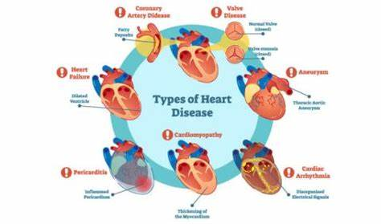
Types of Heart diseases:
Figure 1.1 Types of heart diseases
Fig 1.1 shows various types of heart diseases, coronary artery disease (CAD): CAD is the most common type of heart disease and occurs when the coronary arteries, which supply oxygen-rich blood to the heart muscle, become narrowed or blocked by a buildup of plaque (atherosclerosis). This restricts blood flow to the heart, leading to chest pain (angina), heart attacks (myocardial infarctions), and potentially fatal complications. It is the damage or disease in the heart’s major blood vessels. The usual cause is the buildup of plaque. This causes coronary arteries to narrow, limiting blood flow to the heart. Stroke is the Damage to the brain from interruption of its blood supply.
Heart Failure: Heart failure occurs when the heart is unable to pump blood effectively to meet the body's demands. It can result from various underlying conditions, such as CAD, hypertension, diabetes, or damage to the heart muscle (cardiomyopathy). Symptoms of heart failure include shortness of breath, fatigue, swelling of the legs and ankles, and difficulty performing daily activities.
Arrhythmias: Arrhythmias are abnormal heart rhythms that occur when the electrical impulses that coordinate heartbeats are disrupted. This can cause the heart to beat too fast (tachycardia), too slow (bradycardia), or irregularly. Arrhythmias can lead to palpitations, dizziness, fainting, and in severe cases, cardiac arrest.
Valvular Heart Disease: Valvular heart disease involves abnormalities or damage to the heart valves, which regulate blood flow within the heart chambers. This can result in valve stenosis (narrowing) or regurgitation (leakage), impairing the heart's ability to pump blood efficiently and causing symptoms such as chest pain, fatigue, and shortness of breath.
Congenital Heart Defects: Congenital heart defects are structural abnormalities of the heart that are present at birth. These defects can affect the heart chambers, valves, or major blood vessels, leading to disturbances in blood flow and oxygen delivery. Depending on the severity and type of defect, individuals may experience a range of symptoms from mild to life-threatening.
Importance of early detection and diagnosis of heart disease
Heart disease remains one of the leading causes of morbidity and mortality worldwide, imposing a significant burden on healthcare systems and individuals alike. With its diverse manifestations and potentially fatal consequences, the importance of early detection and diagnosis of heart disease cannot be overstated. Timely identification of cardiac abnormalities enables healthcare providers to initiate appropriate interventions, mitigate risks, and improve patient outcomes.
Early detection plays a pivotal role in preventing the progression of heart disease and reducing associated complications.
Many cardiovascular conditions, including coronary artery disease, arrhythmia, and heart failure, often develop gradually over time, with subtle or asymptomatic presentations in the early stages. As a result, individuals may remain unaware of their underlying cardiac issues until they experience severe symptoms or adverse events. By implementing screening programs and diagnostic protocols that target high-risk populations or individuals with predisposing factors, healthcare providers can identify cardiac abnormalities at an early stage, facilitating prompt intervention and management.
Furthermore, early diagnosis of heart disease offers opportunities for preventive strategies and lifestyle modifications that can mitigate risk factors and improve cardiovascular health. Lifestyle factors such as diet, physical activity, and smoking habits significantly influence the development and progression of heart disease. By identifying individuals at risk and providing education, counseling, and support for adopting healthier behaviors, healthcare providers can empower patients to take proactive steps towards reducing their cardiovascular risk and optimizing their overall well-being.
Early detection of heart disease offers not only clinical advantages but also significant socioeconomic benefits. The economic burden associated with managing advanced stages of heart disease—including hospitalizations, surgical interventions, and long-term care—is substantial. Detecting cardiac abnormalities at an early stage and implementing preventive measures can help reduce healthcare expenditures, optimize resource allocation, and improve the overall quality of care.
The importance of early detection and diagnosis extends beyond improving individual health outcomes to its broader impact on healthcare systems and society. Proactive screening, timely intervention, and preventive strategies contribute to reducing the global burden of heart disease and promoting cardiovascular health.

1.2 Electrocardiogram
An electrocardiogram (ECG or EKG) is a diagnostic test that records the electrical activity of the heart over a period of time. This non-invasive procedure is commonly used to evaluate the heart's rhythm and electrical conduction, helping healthcare providers assess cardiac health and detect various abnormalities.
During an ECG, electrodes are placed on specific locations on the skin, typically on the chest, arms, and legs. These electrodes detect the electrical signals generated by the heart as it contracts and relaxes. The signals are then amplified and recorded by the ECG machine, producing a visual representation of the heart's electrical activity known as an electrocardiogram. The ECG waveform consists of several components, including the P wave, QRS complex, and T wave. The Fig 1.2 shows ECG components P wave, QRS complex and T wave. Each component corresponds to a specific phase of the cardiac cycle: P wave: Represents the depolarization (contraction) of the atria, or upper chambers of the heart. QRS complex: Reflects the depolarization of the ventricles, or lower chambers of the heart, as well as the contraction of the ventricles.
T wave: Indicates the repolarization (relaxation) of the ventricles, preparing them for the next heartbeat.
Arrhythmias: Irregular heart rhythms, such as atrial fibrillation and ventricular tachycardia.
Myocardial infarction (heart attack): Characterized by specific changes in the ECG pattern, such as ST-segment elevation or Q-wave formation.
Cardiac ischemia: Reduced blood flow to the heart muscle, often indicated by ST-segment depression or T-wave inversion.
Cardiac hypertrophy: Enlargement of the heart chambers, resulting in changes to the ECG waveform. ECGs are valuable tools in diagnosing and monitoring various cardiovascular conditions. They are routinely used in clinical settings, including hospitals, clinics, and emergency departments. ECGs can provide valuable information quickly and efficiently, aiding healthcare providers in making timely and accurate decisions regarding patient care and treatment.
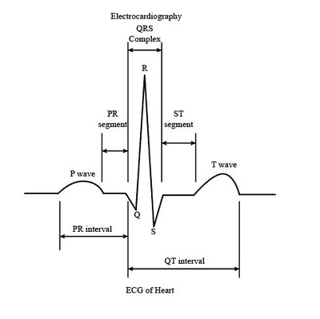
Figure 1.2 ECG components P wave, QRS complex and T wave
Beat Classification:
Beat classification, also known as heartbeat classification or cardiac rhythm classification, is a process of categorizing individual heartbeats into different classes based on their characteristics. This classification is essential in analyzing electrocardiogram (ECG) signals, which record the electrical activity of the heart over time. Beat classification plays a crucial role in various medical applications, including the detection and diagnosis of cardiac arrhythmias, monitoring patient health, and guiding treatment decisions.
Beat classification involves several steps:
Signal Preprocessing: ECG signals are pre-processed to remove noise, baseline wander, and artifacts that may interfere with accurate beat detection and classification.
Feature Extraction: Relevant features are extracted from each heartbeat, such as amplitude, duration, morphology, and intervals (e.g., P-QRS-T intervals).
Classification: Machine learning algorithms or pattern recognition techniques are applied to classify heartbeats into different categories based on extracted features. Common classification approaches include rule-based algorithms, template matching, support vector machines (SVM), artificial neural networks (ANN), and convolutional neural networks (CNN).
Beat Types:
Normal Beats: Normal beats, also known as sinus beats, represent the typical rhythmic contractions of the heart generated by the sinoatrial (SA) node. These beats exhibit regular morphology and timing, characterized by a consistent sequence of P waves, QRS complexes, and T waves on the electrocardiogram (ECG). Normal beats indicate a healthy sinus rhythm and are essential for maintaining efficient cardiac function.
Premature Beats: Premature beats, also called ectopic beats, occur earlier than expected in the cardiac cycle and originate from ectopic foci outside the SA node. Premature beats can manifest as premature atrial contractions (PACs) or premature ventricular contractions (PVCs), depending on their site of origin. PACs arise from abnormal electrical impulses originating in the atria, resulting in premature atrial depolarization and distinctive premature P waves on the ECG. PVCs originate from the ventricles and produce premature, wide QRS complexes on the ECG. While occasional premature beats are common and may not indicate underlying pathology, frequent or sustained ectopic beats can be symptomatic and may require further evaluation.
Supraventricular Arrhythmias: Supraventricular arrhythmias encompass a group of abnormal heart rhythms originating above the ventricles, typically within the atria or atrioventricular (AV) node. These arrhythmias include:
Atrial Fibrillation (AF): AF is the most common sustained cardiac arrhythmia, characterized by rapid, irregular electrical activity in the atria, leading to disorganized atrial contractions. AF may result in palpitations, dizziness, fatigue, and an increased risk of stroke and heart failure.
Atrial Flutter: Atrial flutter is a rhythmic, sawtooth pattern of atrial depolarization, typically occurring at a faster rate than normal sinus rhythm. Atrial flutter may cause palpitations, shortness of breath, and hemodynamic compromise.
Supraventricular Tachycardia (SVT): SVT refers to a rapid heart rate originating above the ventricles, often arising from reentrant circuits within the atria or AV node. SVT can cause palpitations, chest discomfort, dizziness, and syncope.
Ventricular Arrhythmias: Ventricular arrhythmias arise from abnormal electrical activity originating in the ventricles, leading to irregular heart rhythms and compromised cardiac function. These arrhythmias include:
Ventricular Tachycardia (VT): VT is characterized by a rapid, regular or irregular heartbeat originating from the ventricles, typically with a wide QRS complex on the ECG. VT can be sustained or nonsustained and may result in hemodynamic instability and sudden cardiac arrest.
Ventricular Fibrillation (VF): VF is a life-threatening arrhythmia characterized by rapid, chaotic electrical activity in the ventricles, leading to ineffective ventricular contractions and loss of cardiac output. VF results in immediate loss of consciousness and requires immediate defibrillation to restore normal heart rhythm and prevent sudden cardiac death.
Ventricular Ectopic Beats: Ventricular ectopic beats, or premature ventricular contractions (PVCs), originate from ectopic foci within the ventricles, resulting in premature depolarization and distinctive wide QRS complexes on the ECG. Frequent PVCs may indicate underlying cardiac pathology and may warrant further evaluation.

CHAPTER 2
LITERATURE SURVEY

CHAPTER 2

LITERATURE SURVEY
PAPER 1
The study “Time-Series Transformer and Hybrid CNN–Transformer Model for ECG Classification with Genetic Algorithm Optimization” by Krishna et al. (2024), Knowledge-Based Systems presents a framework that combines Transformer models with CNN and genetic algorithm-based optimization. The model incorporates dynamic attention mechanisms and custom positional encoding to improve sequence learning. The genetic algorithm automates hyperparameter tuning, resulting in improved classification accuracy and reduced computational complexity.
PAPER 2
The study “A Cross-Stage Partial Network and a Cross-Attention-Based Transformer for ECG-Based Cardiovascular Disease Decision System” by Lee et al. (2024), IEEE Journal of Biomedical and Health Informatics presents an optimized deep learning architecture that combines cross-stage partial CNN with cross-attention-based Transformer. The model reduces redundant computations while maintaining high accuracy. The cross-attention mechanism enhances feature representation by focusing on important ECG segments.
PAPER 3
The study “CardioAttentionNet: Advancing ECG Beat Characterization with a High-Accuracy and Portable Deep Learning Model” by He et al. (2025), Frontiers in Cardiovascular Medicine introduces an attention-based model for ECG classification. The architecture integrates BiLSTM, multi-head attention, and depth wise separable convolution to improve feature extraction and efficiency. The attention mechanism highlights critical ECG segments, enhancing both classification accuracy and interpretability, making it suitable for real-time and portable healthcare applications.

PAPER 4
The study “Machine Learning-Based Cardiovascular Disease Detection Using Optimal Feature Selection” by Ullah et al. (2024), IEEE Access proposes a machine learning framework that uses feature selection techniques such as FCBF, Relief, and Particle Swarm Optimization (PSO). The selected features are classified using algorithms like Random Forest and Extra Trees. The study demonstrates high classification accuracy and highlights the importance of feature optimization in improving cardiovascular disease detection.
PAPER 5
The study “A Performance Analysis of Advanced Machine Learning Techniques for Arrhythmia Detection” by Philip & Hemalatha (2023), IEEE Conference evaluates multiple machine learning algorithms for ECG classification. The work includes preprocessing, segmentation, and feature extraction techniques, followed by classification using models such as Support Vector Machines and evolutionary optimization methods. The study compares performance using metrics like accuracy and sensitivity.
PAPER 6
The study “LSTM-Based ECG Classification for Continuous Monitoring on Personal Wearable Devices” by Saadatnejad et al. (2019/2020), IEEE Journal of Biomedical and Health Informatics proposes a lightweight ECG classification model suitable for wearable devices. The approach uses wavelet transform for feature extraction and LSTM networks for temporal sequence modeling. The system achieves high accuracy while maintaining computational efficiency, enabling continuous real-time monitoring.
PAPER 7
The study “Multi-ECG Net for ECG Arrhythmia Multi-Label Classification” by Cai et al. (2020), IEEE Access introduces a deep learning model designed for multi-label ECG classification. The model is capable of identifying multiple cardiac abnormalities simultaneously, improving the robustness of automatic ECG diagnosis. The study reports strong performance in terms of micro-F1 score, demonstrating its effectiveness compared to traditional methods.
PAPER 8
The study " Multi-Scale CNN–Transformer by Wei & Li, 2025, Artificial Intelligence in Medicine. Wei and Li developed a multi-scale CNN that processed ECGs at varying resolutions using kernels of different sizes. This allowed the model to detect both short, localized abnormalities and long-duration rhythm disorders. A Transformer then integrated these features into a unified sequence representation, yielding robust arrhythmia detection across multiple scales.
Recent studies have also explored advanced Transformer-based and wavelet-integrated architectures for ECG classification, demonstrating improved performance through multi-scale feature learning and attention mechanisms [9] – [15]. These approaches further highlight the growing importance of Transformer-based models in biomedical signal analysis.
From the reviewed literature, it is observed that most existing approaches rely on hybrid architectures combining convolutional neural networks with Transformer models for ECG classification. While these methods effectively capture local and global features, they often introduce increased computational complexity and dependence on convolution-based feature extraction. In contrast, the present work focuses on a Transformer-based architecture incorporating attention mechanisms and wavelet-inspired feature representation to efficiently model long-range dependencies in ECG signals and improve classification performance.

CHAPTER 3
DEEP LEARNING TECHNIQUES

CHAPTER 3

DEEP LEARNING TECHNIQUES

3.1 Introduction to Deep Learning
Deep learning is a subset of machine learning that focuses on learning hierarchical representations of data using artificial neural networks with multiple layers. Unlike traditional machine learning techniques that rely on handcrafted feature extraction, deep learning models automatically learn meaningful features directly from raw data.
A deep neural network consists of multiple layers of interconnected neurons, where each layer transforms the input data into increasingly abstract representations. Lower layers typically capture simple patterns, while deeper layers capture complex structures and relationships within the data.
Deep learning has demonstrated significant success across various domains such as computer vision, natural language processing, speech recognition, and biomedical signal analysis. Its ability to process large volumes of data and model complex nonlinear relationships makes it highly suitable for tasks involving high-dimensional and sequential data.
In the context of biomedical signal processing, such as electrocardiogram (ECG) analysis, deep learning enables automatic feature extraction and classification of cardiac conditions without requiring manual signal engineering.

3.2 Attention Mechanism
The attention mechanism is a key component in deep learning models, particularly in the field of natural language processing (NLP) and computer vision. It allows models to focus on different parts of the input data (e.g., words in a sentence, pixels in an image) with varying degrees of importance, rather than treating all parts of the input equally. This selective attention mechanism helps improve the performance of the
model by enabling it to dynamically weigh the importance of different inputs during processing. Fig 3.1 shows the attention mechanism.
Context and Query: At its core, the attention mechanism involves context and a query. The context represents the input data (e.g., a sequence of words in a sentence), while the query represents a specific aspect or feature of interest within the context (e.g., a particular word in the sentence).

Attention Scores: The attention mechanism computes attention scores for each element in the context based on its relevance to the query. These attention scores quantify the importance or relevance of each element in the context with respect to the query.
Attention Weights: The attention scores are then transformed into attention weights through a normalization process (e.g., using the SoftMax function). These attention weights represent the relative importance of each element in the context, with higher weights assigned to more relevant elements and lower weights assigned to less relevant elements.
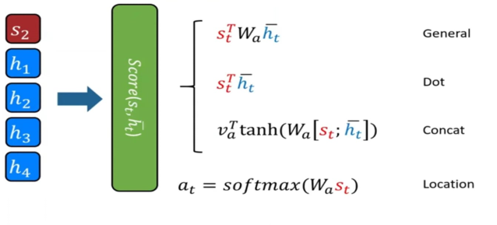
Weighted Sum: Finally, the attention mechanism computes a weighted sum of the elements in the context, where each element is multiplied by its corresponding attention weight. This weighted sum, often referred to as the attention context or attended representation, captures the model's focused attention on the most relevant parts of the input data with respect to the query.
Figure 3.1 Attention Mechanism

3.2.1 Working of Attention Mechanism
Contextual Relevance: In many machine learning tasks, especially those involving sequences like sentences or images, different parts of the input may have varying levels of relevance to the output or prediction.
Weighted Emphasis: The attention mechanism assigns weights to different parts of the input, emphasizing elements that are more relevant to the task at hand. It effectively provides a mechanism for the model to "pay attention" to specific regions or features.
Dynamic Attention: Importantly, attention is often dynamic and can be recalibrated for each input or step in a sequence. This means that the model can adaptively shift its focus based on the current context, allowing for a more nuanced understanding of the input data.
Components of Attention: There are different components in the attention mechanism. The key components include the query, key, and value vectors. The query represents the current input, the key represents elements in the input to compare against, and the value represents the information to be extracted. The attention weight is computed based on the compatibility between the query and key, and the weighted sum of values is used for the final output.
Self-Attention: Self-attention, also known as intra-attention, is a type of attention mechanism where the model attends to different positions in the input sequence. Transformer architectures, widely used in NLP tasks, leverage self-attention to capture contextual information from the entire sequence.
The attention mechanism can be applied in various deep learning architectures, including recurrent neural networks (RNNs), convolutional neural networks (CNNs), and transformer models. In NLP tasks, such as machine translation and text summarization, attention mechanisms have been instrumental in improving the accuracy and fluency of generated outputs by allowing models to selectively attend to relevant words in the input sequence. Similarly, in computer vision tasks, attention mechanisms have been used to enhance object detection, image captioning, and visual question answering by enabling models to focus on salient regions of an image.

3.2.2 Advantages of Attention Mechanism
The integration of attention mechanisms into ECG analysis models offers several advantages, including enhanced feature localization, improved interpretability, selective information processing, adaptability to variable-length sequences, and personalized diagnosis. These advantages contribute to the development of more accurate, reliable, and clinically relevant diagnostic tools for assessing cardiac health and identifying cardiac abnormalities in patients.
Enhanced Feature Localization: Attention mechanisms can help identify and focus on specific segments of the ECG signal that are most relevant for a particular diagnostic task. By dynamically allocating attention to informative regions of the signal, the model can effectively localize features associated with cardiac abnormalities, such as abnormal waveforms or arrhythmias.
Improved Interpretability: Attention mechanisms provide insights into which parts of the ECG signal contribute most to the model's predictions. This enhanced interpretability can aid clinicians in understanding the reasoning behind the model's decisions, making it easier to trust and validate the diagnostic outputs generated by the model.
Selective Information Processing: ECG signals often contain noise and artifacts that can interfere with accurate diagnosis. Attention mechanisms enable the model to selectively attend to informative components of the signal while ignoring irrelevant noise. This selective information processing can improve the robustness and accuracy of the diagnostic model, particularly in noisy clinical environments.
Adaptability to Variable-Length Sequences: ECG signals can vary in length depending on factors such as the duration of the recording and the patient's heart rate. Attention mechanisms allow the model to dynamically adapt its focus to different segments of the ECG signal, regardless of their length. This adaptability enables the model to effectively handle variable-length sequences and capture important temporal patterns in the signal.
Personalized Diagnosis: Attention mechanisms can be personalized to individual patients' ECG characteristics and medical history. By learning patient-specific patterns and preferences, the model can tailor its attention to features that are most relevant for each patient's unique cardiac profile, leading to more personalized and accurate diagnostic assessments.

3.2.3 Applications of Attention Mechanism
The application of attention mechanisms in the analysis of electrocardiogram (ECG) signals has several potential applications in the field of cardiology and healthcare:
Arrhythmia Detection: Attention mechanisms can be used to highlight specific segments of the ECG signal that are indicative of arrhythmias or irregular heartbeats. By focusing on relevant patterns and abnormalities in the signal, attention-based models can improve the accuracy of arrhythmia detection and classification, aiding in the diagnosis and management of cardiac arrhythmia.

Ischemia Detection: Attention mechanisms can help identify ischemic changes in the ECG signal, which indicate insufficient blood flow to the heart muscle. By directing attention to characteristic ST-segment deviations or T-wave abnormalities associated with myocardial ischemia, attention-based models can assist in the early detection and diagnosis of ischemic heart disease.
ECG Denoising: ECG signals are often contaminated with noise and artifacts, which can interfere with accurate diagnosis. Attention mechanisms can selectively focus on informative components of the signal while suppressing irrelevant noise, thereby improving the quality and reliability of ECG signal denoising techniques.
Feature Localization: Attention mechanisms can localize specific features or landmarks in the ECG signal, such as the P-wave, QRS complex, and T-wave. By directing attention to these key features, attention-based models can facilitate automated ECG analysis tasks, such as heartbeat segmentation, interval measurement, and feature extraction.
Long-term Monitoring: Attention mechanisms can be applied to long-term ECG monitoring data, such as Holter recordings or ambulatory ECGs. By dynamically allocating attention to relevant segments of the continuous ECG signal, attention-based models can assist in the detection of transient arrhythmia, silent ischemia, and other cardiac abnormalities that may occur intermittently over time.
Personalized Risk Assessment: Attention mechanisms can be personalized to individual patients ECG characteristics, medical history, and risk factors. By learning patient-specific patterns and preferences, attention-based models can tailor their analysis to identify subtle changes or abnormalities in the ECG signal that may indicate increased cardiovascular risk or the need for further evaluation.
In this work, attention mechanisms are integrated within a Transformer-based architecture for ECG signal classification. The model utilizes self-attention to capture global temporal dependencies and cross-attention to enhance multi-scale feature representation, enabling more accurate detection of cardiac abnormalities.

3.3 Transformer Model
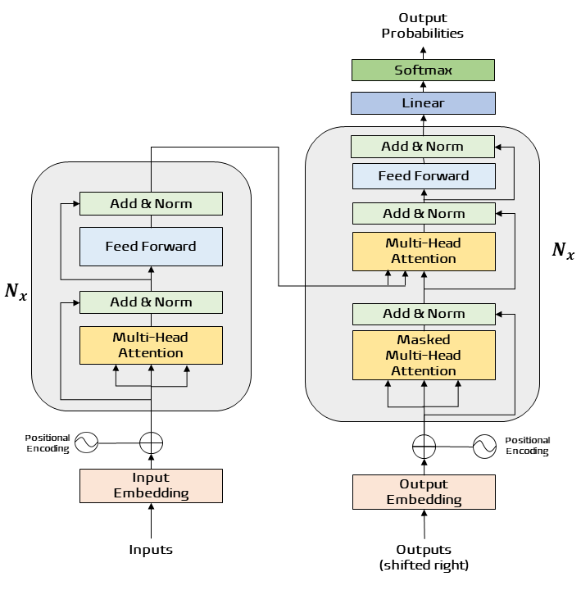
The Transformer Network is a deep learning model introduced in the landmark paper Attention is all you need. Fig 3.2 shows the transformer network. It is primarily designed to handle sequential data like language but does so in a way that replaces traditional recurrent or convolutional neural networks with a more efficient architecture:
Figure 3.2 Transformer Model

3.3.1 Working of Transformer Model
The core working mechanism of the Transformer model can be broken down into the following key steps:
Attention Mechanism: The core of the Transformer is its self-attention mechanism, which allows the model to weigh the importance of different parts of the input sequence.
Encoder-Decoder Architecture: It typically has two main parts:
Encoder: Processes the input sequence and generates context-aware embeddings.
Decoder: Takes the embeddings and predicts output sequences, like translations in NLP tasks.
Feedforward Layers: These are used after the attention mechanism for further processing.
Position Encoding: Since Transformers lack inherent order awareness, they use position encodings to represent the sequence order.

3.3.2 Advantages of Transformer Model
Parallelism: Unlike RNNs, Transformers process sequences in parallel rather than step-by-step, making them faster and scalable.
Flexibility: They work well across a range of applications, from text translation to image recognition.
State-of-the-Art Performance: Transformers have set benchmarks in tasks like natural language understanding and generation (e.g., GPT and BERT models).
Attention-Based Efficiency: The self-attention mechanism enables the model to capture long-range dependencies effectively.

3.3.3 Applications for Transformer Model
Transformer models find extensive applications across multiple domains. In Natural Language Processing (NLP), they are the backbone of tasks such as language translation, text summarization, sentiment analysis, and question-answering systems. Tools like Google Translate and GPT-based models owe their success to Transformers. In computer vision, Vision Transformers (ViTs) are used for image classification and object detection, pushing the boundaries of image-based AI. Technology is also employed in speech processing, facilitating advancements in automatic speech recognition and synthesis. Beyond these, Transformers power generative AI models for creating coherent text, art, or even music, and are pivotal in gaming for designing decision-making AI agents.

3.4 Wavelet Model
Wavelet-based models are widely used in signal processing to analyse signals in both time and frequency domains. Unlike traditional fixed transforms, a Wavelet Model incorporates learnable parameters that allow the system to adapt its multi-resolution analysis (MRA) specifically to the dataset during the training phase.
In biomedical signal processing, particularly in electrocardiogram (ECG) analysis, the Wavelet Model is highly effective in capturing transient characteristics such as sharp peaks, sudden changes, and irregular patterns present in heart signals. By utilizing learnable weights, the model can optimize the extraction of both fine-grained and high-level patterns in ECG signals, significantly improving the quality of features passed to the attention layers.

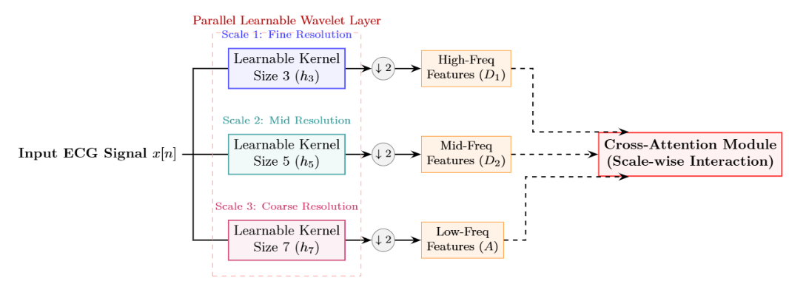
Figure 3.3 Wavelet Model

3.4.1 Working of Wavelet Model
Wavelet transformation decomposes a signal into components at multiple frequency scales using scaling and translation operations applied to a base wavelet function. This decomposition enables the analysis of signals at different resolutions.
- High-frequency components capture rapid changes such as noise and sharp transitions (e.g., QRS complex in ECG).
- Low-frequency components capture overall trends and smooth variations (e.g., baseline drift).
Traditional wavelet networks use wavelet functions as activation functions in hidden layers, where each neuron represents a wavelet basis function. These networks adjust parameters such as scaling factors, translation parameters, and weights during training to model nonlinear relationships.
However, in this work, instead of implementing a full wavelet neural network, wavelet principles are integrated into the feature representation process, enabling the model to effectively capture both temporal and frequency-domain characteristics of ECG signals within a Transformer-based architecture.

3.4.2 Advantages of Wavelet Network
Time-Frequency Analysis: Simultaneously captures temporal and spectral information from ECG signals.
Multi-Resolution Capability: Enables analysis of signals at different scales, improving feature richness.
Noise Reduction: Helps isolate meaningful signal components while suppressing noise.
Improved Feature Extraction: Enhances the model’s ability to detect subtle abnormalities in ECG patterns.

3.4.3 Applications of Wavelet Network
Wavelet-based techniques are widely used across various domains:
Biomedical Signal Analysis: ECG and EEG signal processing for detecting abnormalities and classification.
Image Processing: Image compression, denoising, and feature extraction.
Speech Processing: Capturing variations in speech signals for recognition tasks.
Fault Detection Systems: Identifying anomalies in mechanical and industrial systems.
Time-Series Analysis: Financial forecasting and predictive modelling.

CHAPTER 4
METHODOLOGY

CHAPTER 4

METHODOLOGY
This chapter describes the complete methodology used for ECG arrhythmia classification. The proposed pipeline consists of several stages including ECG signal preprocessing, heartbeat segmentation, dataset balancing, feature learning, and classification using the proposed Cross-Attentive Wavelet Transformer (CAWT) architecture. Unlike traditional machine learning approaches that rely on manually engineered features, the CAWT network performs automatic end-to-end feature extraction directly from raw ECG heartbeat segments. The architecture combines time-domain convolutional feature extraction, multi-resolution spectral analysis, and transformer-based cross-attention mechanisms to capture both morphological and frequency characteristics of ECG signals for accurate arrhythmia classification.

4.1 ECG Dataset
MIT-BIH arrhythmias database: The database comprises 48-records of 2 channel ECG signals of 30-min duration obtained from 47 subjects between 1975 and 1979 at the BIH Arrhythmia Laboratory. Twenty-three recordings were selected randomly from a set of 4000 ECG records from subjects of inpatients and outpatients at Boston's Beth Israel Hospital, remaining 25 were selected from the same set having clinically arrhythmias. Twenty-five men of age 32 to 89 years, and twenty-two women aged 23-89 years were selected. The database consists of 116,137 QRS complexes. The ECG signals were sampled at 360 samples per second with 11-bit resolution over a 10-mV range and band pass-filtered at 0.1-100 Hz. It was verified by independent cardiologist to annotate for both timing and beat class information. The different beats include Normal beat (N), LBBB, RBBB, atrial premature beats (APB), and premature ventricular complex (PVC) of recorded signals, which are summarized in Table 1.
AAMI standard: The MIT-BIH heartbeat types are combined according to the Association for the Advancement of Medical Instrumentation (AAMI) recommendation. It emphasizes the problem of classifying ventricular ectopic beats (VEBs) from the non-ventricular ectopic beats shown in Fig 4.1. The following five types of heartbeat are classified according to AAMI standard:

Found 48 records

Total beats extracted: 109466
Table 4.1 Distribution of different arrhythmia of MIT-BIH database.
Class | Count | Percentage
Normal (N) | 90606 | 82.77%
Supraventricular (S) | 2781 | 2.54%
Ventricular (V) | 7235 | 6.61%
Fusion (F) | 802 | 0.73%
Unknown (Q) | 8042 | 7.35%

1.N (Normal beat)
2.S (supraventricular ectopic beats (SVEBS))
3.V (ventricular ectopic beats (VEBS))
4.F (fusion beats)
5.Q (unclassified beats, including paced beats)
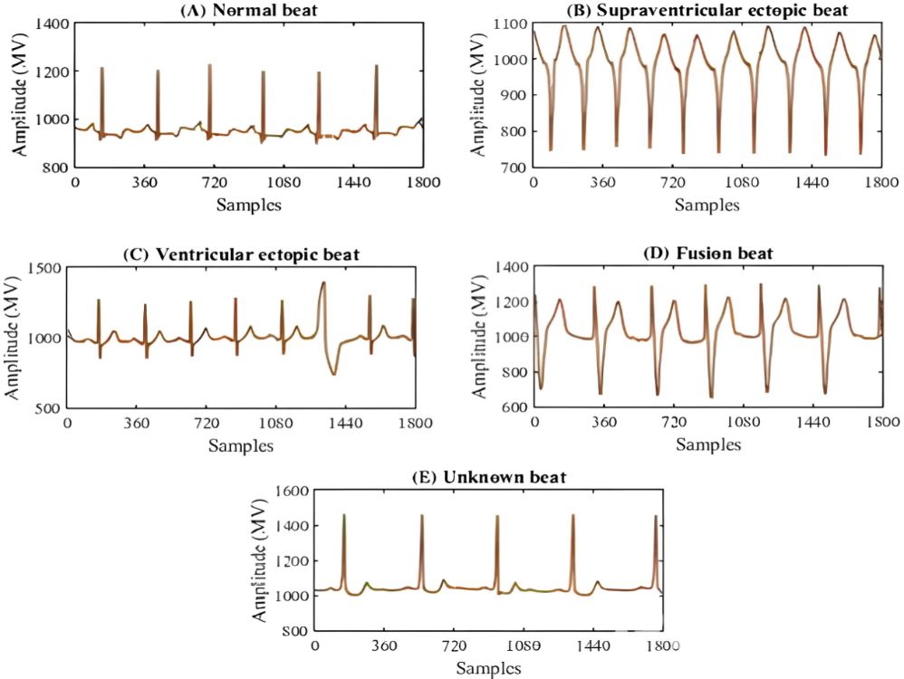

Figure 4.1 ECG Signal in AAMI Standard Heartbeat Classes

4.2 Preprocessing
Electrocardiogram (ECG) signals collected from real-world environments often contain different types of noise and signal distortions. These disturbances may occur due to patient movement, electrode displacement, muscle activity, or interference from nearby electrical devices. Such artifacts can significantly degrade the quality of ECG signals and may negatively affect the performance of machine learning and deep learning models used for arrhythmia classification. Therefore, an effective preprocessing stage is necessary before performing feature extraction and classification.
The preprocessing pipeline implemented in this study consists of the following steps: raw ECG signal acquisition, denoising, R-peak detection, heartbeat segmentation, and signal normalization. These steps ensure that the ECG signals are clean, consistent, and suitable for further analysis.
Raw ECG Signal Acquisition
The raw ECG signal represents the original electrical activity of the heart recorded by sensors placed on the patient's skin. These signals are obtained from the MIT-BIH Arrhythmia Database, which contains annotated ECG recordings collected from multiple subjects. Each ECG record contains continuous heart activity including the P wave, QRS complex, and T wave, which together represent a complete cardiac cycle.
However, raw ECG signals often contain various noise components that can interfere with accurate analysis. The major noise sources include:
Baseline Drift: Baseline drift refers to slow variations in the ECG signal baseline caused by breathing, patient movement, or electrode motion. These low-frequency fluctuations shift the ECG signal up and down over time.
Powerline Interference: Electrical equipment surrounding the recording environment may introduce periodic noise at 50 Hz or 60 Hz, which appears as a sinusoidal disturbance in the ECG signal.
Muscle Noise: Muscle contractions generate high-frequency noise known as electromyographic (EMG) interference. This noise may distort important ECG waveform components.

Denoising Process
To ensure accurate ECG analysis, the recorded signals must be cleaned by removing noise while preserving the important morphological characteristics of the ECG waveform. The denoising process implemented in this work consists of two main stages: baseline drift removal and wavelet-based noise reduction.
Baseline Drift Removal
Baseline drift is removed using a median filtering technique. Two median filters with window sizes of 200 ms and 600 ms are applied sequentially to estimate the baseline trend of the ECG signal.
The 200 ms median filter removes sharp peaks such as the P wave, QRS complex, and T wave, allowing the slow-varying baseline component to be estimated. The 600 ms median filter captures the overall baseline trend of the signal. The extracted baseline is then subtracted from the original ECG signal, producing a corrected ECG waveform with reduced baseline fluctuations.
Wavelet Transform for Noise Reduction
After baseline correction, further noise suppression is performed using the Discrete Wavelet Transform (DWT). The wavelet transform decomposes the ECG signal into multiple frequency bands, allowing noise components to be isolated and removed effectively.
High-frequency noise caused by muscle artifacts and electrical interference is reduced by applying thresholding to the wavelet detail coefficients. Once the noise components are suppressed, the denoised ECG signal is reconstructed using the Inverse Discrete Wavelet Transform (IDWT). This technique preserves the important morphological features of the ECG waveform while removing unwanted disturbances.
R-Peak Detection
Accurate detection of the R-peaks is a crucial step for ECG signal segmentation. The R-peak corresponds to the highest amplitude point of the QRS complex and serves as a reliable reference point for identifying individual heartbeats.
In this study, R-peak detection is performed using the Pan–Tompkins Algorithm, a widely used method for detecting QRS complexes in ECG signals. The algorithm consists of several signal processing steps including bandpass filtering, differentiation, squaring, and moving window integration. These operations enhance the QRS complex while suppressing noise and other waveform components.
The detected R-peaks are used as reference points for segmenting the ECG signal into individual heartbeat cycles.
Heartbeat Segmentation
Once the R-peaks are detected, the continuous ECG signal is divided into individual heartbeat segments. Each heartbeat is extracted within a fixed time window centered around the detected R-peak.
In this work, approximately 0.25 seconds of signal before the R-peak and 0.27 seconds after the R-peak are extracted to ensure that the entire cardiac cycle, including the P wave, QRS complex, and T wave, is captured. Each segmented heartbeat is then resampled to a fixed length of 187 samples. This ensures that all heartbeat signals have a consistent input size, which is necessary for training machine learning and deep learning models.
Signal Normalization
After segmentation, each heartbeat signal is normalized to reduce amplitude variations and improve model training stability. Normalization is performed using min–max scaling, which rescales the signal values between 0 and 1.
The normalization process can be expressed as:

$$X_{norm}=\frac{X-X_{min}}{X_{max}-X_{min}}$$
where
X represents the original ECG signal,
X_{min} is the minimum value of the signal, and
X_{max}​ is the maximum value of the signal.

Normalization ensures that the ECG signals maintain consistent amplitude ranges, allowing machine learning and deep learning models to learn relevant patterns more effectively.
After completing all preprocessing steps, the ECG dataset consists of segmented heartbeat signals with a fixed length of 187 samples. Each segment corresponds to one of the five arrhythmia classes defined by the AAMI standard:
Normal (N)
Supraventricular (S)
Ventricular (V)
Fusion (F)
Unknown (Q)
These preprocessed signals are then used as inputs for subsequent stages of the system, including feature extraction, dataset balancing, and arrhythmia classification using machine learning and the proposed CAWT deep learning network.
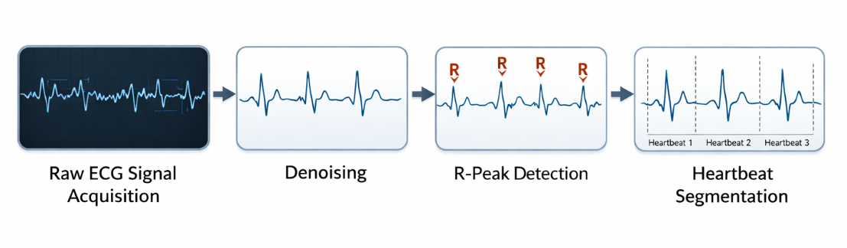
Figure 4.2 ECG Preprocessing Pipeline

4.3 Balancing Dataset
The MIT-BIH Arrhythmia dataset is highly imbalanced, where the Normal (N) heartbeat class constitutes more than 80% of the total samples, while other arrhythmia classes such as Supraventricular (S), Ventricular (V), Fusion (F), and Unknown (Q) appear much less frequently. Training a deep learning model directly on such data can cause the model to become biased toward the majority class, leading to poor detection of rare arrhythmias. To address this issue, a multi-stage dataset balancing strategy was implemented at the data level, batch level, and loss level.
First, the Synthetic Minority Over-sampling Technique (SMOTE) was applied to the training dataset after performing a stratified train–validation split. SMOTE generates synthetic samples for minority classes by interpolating between existing samples in the feature space, allowing the model to learn more representative patterns of rare arrhythmias instead of simply duplicating data.
Second, a Weighted Random Sampler was used within the PyTorch Data Loader to ensure balanced mini-batches during training. This sampling strategy assigns higher selection probabilities to minority class samples and lower probabilities to majority class samples. As a result, each training batch contains a more balanced representation of all arrhythmia classes, preventing the model from being dominated by the Normal class.
Finally, class weights were incorporated into the Focal Loss function to emphasize difficult or minority class samples during training. By penalizing misclassification of rare arrhythmias more strongly than common ones, the loss function encourages the model to focus on learning discriminative features for underrepresented heartbeat types.
This combined strategy of balancing the dataset at the data, batch, and loss levels improves the model’s ability to detect minority arrhythmias and contributes significantly to the high classification performance achieved by the proposed CAWT architecture.
Table 4.2 Multi-Stage Dataset Balancing Strategy.
Technique | Level | Purpose
SMOTE | Data Level | Generates synthetic samples for minority classes
Weighted Random Sampler | Batch Level | Ensures balanced mini-batches during training
Class Weights + Focal Loss | Loss Level | Penalizes errors on minority classes more heavily

4.4 Feature Extraction

In traditional ECG classification systems, feature extraction is performed using handcrafted statistical or spectral features. However, in modern deep learning approaches, feature extraction is learned automatically by neural networks. In this work, the proposed Cross-Attentive Wavelet Transformer (CAWT) model performs automatic feature extraction directly from the preprocessed ECG signals.
The model uses two complementary feature extraction branches: a Wavelet-based feature extractor and a Time-domain feature extractor. These branches capture different characteristics of the ECG signal, enabling the model to learn both frequency-based and temporal patterns associated with cardiac arrhythmias.
Wavelet Feature Extraction
The wavelet feature extractor captures multi-resolution frequency information from the ECG signal. It uses convolutional filters of different kernel sizes to analyze the signal at multiple frequency bands. This approach mimics the behavior of wavelet transforms by decomposing the signal into high-frequency and low-frequency components. These features help the model detect morphological variations in ECG waveforms such as the P-wave, QRS complex, and T-wave.
Time-Domain Feature Extraction
In addition to frequency features, the model extracts temporal features using a series of convolutional layers designed to capture patterns in the time domain. These layers learn representations related to heartbeat rhythm, signal amplitude variations, and waveform structures.
Cross-Attention Feature Fusion
After extracting features from both branches, the CAWT architecture employs a cross-attention mechanism to integrate the wavelet-based and time-domain features. This mechanism allows the model to learn relationships between different feature representations and enhance important signal characteristics relevant for arrhythmia classification.
By combining wavelet-inspired feature extraction with transformer-based attention mechanisms, the model can effectively learn discriminative representations from ECG signals without requiring manually engineered features. This deep feature extraction process significantly improves the model's ability to classify different arrhythmia types.
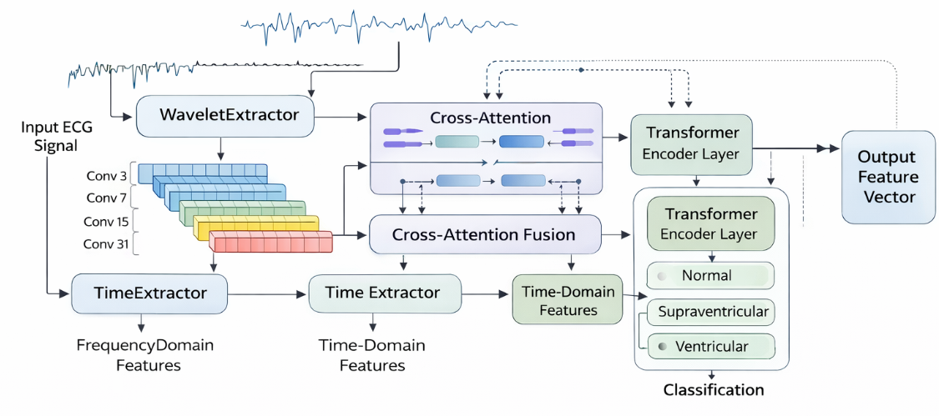
Figure 4.3 Feature Extraction using CAWT Architecture

4.5 Automatic Feature Learning and Selection
In traditional machine learning approaches, feature selection is performed manually by selecting statistical, temporal, or spectral features that best represent ECG signals. However, in this project the traditional feature selection stage is replaced by an end-to-end automatic learning mechanism. The proposed Cross-Attentive Wavelet Transformer (CAWT) network automatically identifies and prioritizes the most discriminative patterns directly from the 187-sample ECG heartbeat segments. Instead of relying on handcrafted feature engineering, the model learns relevant features during training through specialized architectural components that capture both spectral and temporal characteristics of ECG signals.

4.5.1 Multi-Resolution Spectral Feature Learning
The wavelet-domain branch of the CAWT architecture performs spectral feature selection using parallel convolutional layers with different kernel sizes (3, 7, 15, and 31). This structure functions as a multi-resolution filter bank that analyzes the ECG signal across different frequency bands. Smaller kernels focus on high-frequency components such as sharp QRS complexes and rapid waveform variations, while larger kernels capture low-frequency components including baseline drift and ST-segment variations. Through training, the network automatically learns which frequency components are most relevant for identifying specific arrhythmia types.

4.5.2 Morphological Feature Extraction (Time-Domain)
The time-domain branch extracts morphological features using one-dimensional convolutional layers that act as automatic pattern detectors. These filters scan the ECG waveform to learn important structural characteristics such as P-wave presence, QRS complex width, and T-wave morphology. Because the training data is balanced using SMOTE and batch sampling techniques, the model becomes capable of learning distinctive waveform patterns associated with rare arrhythmias such as Supraventricular and Fusion beats.

4.5.3 Cross-Attention Based Feature Selection
The cross-attention mechanism integrates the spectral and temporal representations learned by the two branches. It computes attention scores between the features extracted from the wavelet and time-domain modules, allowing the model to dynamically emphasize the most informative features while suppressing irrelevant signal components. This adaptive weighting process enables the CAWT network to focus on critical ECG characteristics associated with different arrhythmia classes, thereby improving classification performance.
Through this automatic feature selection process, the CAWT architecture eliminates the need for manual feature engineering and allows the model to learn optimal representations directly from the ECG signals.

4.6 Classification
After preprocessing, dataset balancing, feature extraction, and automatic feature selection, the final stage of the proposed system is the classification of ECG heartbeats into different arrhythmia categories. In this project, classification is performed using the Cross-Attentive Wavelet Transformer (CAWT) network, which combines convolutional feature extraction with transformer-based attention mechanisms to achieve high classification accuracy.
The CAWT architecture consists of two parallel feature extraction branches: a Wavelet-Domain branch and a Time-Domain branch. The wavelet branch extracts multi-resolution spectral features using convolutional filters with different kernel sizes, while the time-domain branch learns morphological features from the ECG waveform using one-dimensional convolutional layers. These two feature representations capture complementary information about the ECG signal.
To effectively integrate the extracted features, a bidirectional cross-attention mechanism is applied between the wavelet and time-domain representations. This attention mechanism allows each branch to learn from the other by exchanging contextual information and highlighting the most relevant signal characteristics. Rotary positional encoding is also incorporated to preserve the sequential structure of the ECG signal during the attention process.
The fused feature representations are then aggregated using global average pooling, producing a compact feature vector that summarizes the most discriminative information from the heartbeat segment. This feature vector is passed through fully connected layers that perform the final classification task. The output layer contains five neurons corresponding to the five arrhythmia classes defined by the AAMI standard: Normal (N), Supraventricular (S), Ventricular (V), Fusion (F), and Unknown (Q).
During training, the model is optimized using a class-weighted Focal Loss function with label smoothing, which helps address class imbalance and improves the detection of rare arrhythmia patterns. The AdamW optimizer and OneCycle learning rate scheduling are employed to ensure stable and efficient training.
By combining deep feature learning with transformer-based attention mechanisms, the CAWT model effectively captures both temporal and spectral characteristics of ECG signals, enabling accurate and robust classification of cardiac arrhythmias.

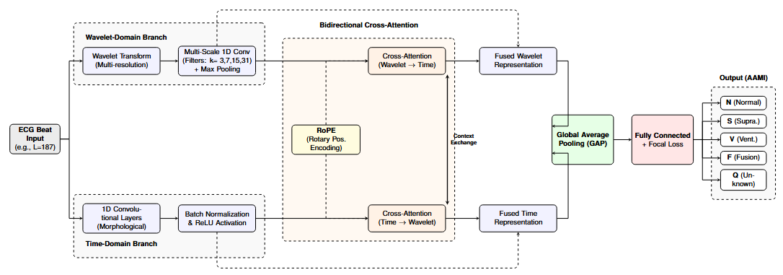
Figure 4.4 CAWT Network Architecture for ECG Classification

4.7 Evaluation Metrics for Arrhythmia Classification
In the evaluation of the ECG arrhythmia classification model, several key performance metrics are used to assess its effectiveness and reliability. These metrics help in understanding how well the model classifies ECG signals into different arrhythmia categories.
Accuracy: It represents the overall correctness of the model by calculating the ratio of correctly classified instances to the total instances. It is given by:
$Accuracy=\frac{TP+TN}{TP+TN+FP+FN}$
where TP (True Positives), TN (True Negatives), FP (False Positives), and FN (False Negatives) denote the classification outcomes.
Precision (Positive Predictive Value): Precision measures how many of the predicted positive cases are actually correct. It is calculated as:
$$Precision=\frac{TP}{TP+FP}$$
Recall (Sensitivity or True Positive Rate): Recall determines how well the model identifies actual positive cases. It is given by:
$Recall=\frac{TP}{TP+FN }$
A higher recall value signifies that fewer actual positive cases are missed.
F1-Score: The F1-score provides a balance between precision and recall, especially useful in imbalanced datasets. It is computed as:
$F1\text{-}Score=2×\frac{Precision×Recall}{Precision+Recall}$
A higher F1-score indicates a strong balance between precision and recall.
Specificity (True Negative Rate): Specificity evaluates how well the model identifies negative cases. It is expressed as:
$Specificity=\frac{TN}{TN+FP }$
Confusion Matrix: This matrix provides a visual representation of model performance, displaying the counts of actual versus predicted classifications for each arrhythmia category. It helps in analysing misclassification patterns.
ROC Curve and AUC (Area Under the Curve): The Receiver Operating Characteristic (ROC) Curve illustrates the trade-off between sensitivity and specificity at different classification thresholds. The AUC value indicates the model’s ability to distinguish between classes, with a value closer to 1 signifying better performance.

CHAPTER 5
SOFTWARE

CHAPTER 5

SOFTWARE
In this project, the proposed Cross-Attentive Wavelet Transformer (CAWT) model was implemented and trained using the Google Colaboratory platform. Google Colab provides a cloud-based environment that allows researchers to run Python programs, train deep learning models, and perform data analysis without requiring high-end local hardware. The platform offers access to GPU acceleration, which significantly reduces the training time of deep learning models.

5.1 Google Colaboratory
Google Colaboratory is a free cloud-based Jupyter notebook environment provided by Google that allows users to write and execute Python code through a web browser. It is widely used for machine learning and deep learning experiments because it provides access to powerful computing resources such as GPUs and TPUs.
In this project, Google Colab was used to implement and train the proposed CAWT model using GPU acceleration. The ECG dataset was uploaded to the Colab environment and processed using Python libraries. The training, validation, and testing of the deep learning model were carried out entirely within the Colab environment.
The platform also allows easy integration with Google Drive, enabling efficient dataset storage and experiment management. The availability of built-in visualization tools and notebook-based execution makes Google Colaboratory an ideal platform for rapid experimentation and model development.

5.2 Software Libraries
Several Python libraries were used in this project for medical signal processing, deep learning model development, data analysis, and visualization. These libraries provide optimized functions that simplify complex tasks such as ECG signal processing, model training, and performance evaluation.
The main libraries used in this project include WFDB, SciPy, PyTorch, NumPy, Scikit-learn, Imbalanced-learn, Matplotlib, and Seaborn.

5.2.1 WFDB
WFDB (WaveForm DataBase) is a specialized library designed for reading and processing physiological signal databases such as the MIT-BIH Arrhythmia dataset. It provides functions for loading ECG signals stored in .dat files along with their corresponding annotation files (.atr).
In this project, WFDB was used to load the ECG recordings and the cardiologist-annotated heartbeat labels from the MIT-BIH database. These annotations were used to extract individual heartbeat segments for arrhythmia classification.
5.2.2 SciPy
SciPy is a scientific computing library that provides advanced mathematical and signal processing functions. The scipy.signal module was used for digital signal processing tasks.
In this project, SciPy was used for resampling ECG signals to a fixed length of 187 samples per heartbeat, ensuring that all input signals had a consistent format suitable for deep learning model training.
5.2.3 PyTorch
PyTorch is an open-source deep learning framework widely used for research and industrial applications. It provides tools for building neural networks, automatic differentiation, and GPU-accelerated training.
In this project, PyTorch served as the primary framework for implementing the proposed Cross-Attentive Wavelet-Transformer (CAWT) architecture. PyTorch modules were used to construct convolutional layers, attention mechanisms, transformer encoder blocks, and classification layers. Additionally, PyTorch's mixed-precision training utilities (torch.amp) were used to improve training efficiency on the Google Colab GPU environment.
The trained model was exported using TorchScript, converting the .pth model into a mobile-optimized .pt format suitable for deployment in the Android application.

5.2.4 NumPy
NumPy (Numerical Python) is a core library for numerical computation in Python. It provides support for multi-dimensional arrays and efficient mathematical operations.
In this project, NumPy was used for array manipulation, signal normalization, and mathematical operations required during ECG preprocessing and feature preparation.
5.2.5 Scikit-Learn
Scikit-Learn is a widely used machine learning library that provides tools for model evaluation, data preprocessing, and statistical analysis.
In this project, Scikit-Learn was used for dataset splitting (train_test_split) and evaluation metrics such as Accuracy, Precision, Recall, F1-Score, and AUROC, which were used to assess the performance of the CAWT model.
5.2.6 Imbalanced-Learn
Imbalanced-Learn is a library designed to handle imbalanced datasets. It provides advanced oversampling techniques such as SMOTE.
In this project, SMOTE (Synthetic Minority Oversampling Technique) was used to generate synthetic samples for minority arrhythmia classes. This helped reduce class imbalance in the MIT-BIH dataset and improved the model's ability to detect rare arrhythmia patterns.
5.2.7 Matplotlib
Matplotlib is a Python library used for data visualization. It allows the generation of plots, graphs, and charts to visualize data patterns and model performance.
In this project, Matplotlib was used to visualize ECG signals and plot training curves such as loss and accuracy during model training.
5.2.8 Seaborn
Seaborn is a statistical data visualization library built on top of Matplotlib. It provides enhanced visualization capabilities for creating informative statistical graphics.
In this project, Seaborn was used to generate confusion matrices and heatmaps to visualize the classification performance of the CAWT model.

5.3 Layers Implementation Using Deep Learning
The proposed Cross-Attentive Wavelet-Transformer (CAWT) architecture consists of several deep learning layers that work together to extract meaningful features from ECG signals and perform arrhythmia classification.
5.3.1 Convolutional Layers
One-dimensional convolutional layers are used to process ECG signals, which are sequential time-series data. These layers apply learnable filters that slide across the input signal to detect important waveform patterns.
In the Time-Domain branch, convolutional filters with kernel sizes such as 7, 5, and 3 are used to capture morphological patterns including the P-wave, QRS complex, and T-wave.
In the Wavelet-Domain branch, multi-resolution convolutional filters with kernel sizes 3, 7, 15, and 31 are applied to analyze the signal at different frequency scales.
5.3.2 Batch Normalization Layer
Batch Normalization is used to stabilize and accelerate the training process by normalizing the activations of each layer. This reduces internal covariate shift and allows the network to converge faster.
5.3.3 Activation Function (GELU)
The Gaussian Error Linear Unit (GELU) activation function introduces non-linearity into the model. GELU is commonly used in transformer architectures because it provides smoother activation compared to traditional functions such as ReLU.
5.3.4 Max Pooling Layer
Max Pooling layers reduce the dimensionality of feature maps by selecting the maximum value within a given window. This operation helps retain the most significant features while reducing computational complexity.
5.3.5 Cross-Attention Layer
The Cross-Attention mechanism enables interaction between the time-domain and wavelet-domain feature representations. It uses Query, Key, and Value matrices to identify relationships between morphological and spectral features of the ECG signal.
This mechanism allows the model to emphasize relevant patterns while suppressing noise and irrelevant information.
5.3.6 Rotary Positional Encoding (RoPE)
Rotary Positional Encoding is used to provide positional information to the transformer model. Unlike traditional positional embeddings, RoPE encodes relative positional relationships between elements of the sequence, allowing the model to better understand temporal dependencies within ECG signals.
5.3.7 DropPath Regularization
DropPath is a regularization technique that randomly drops entire network paths during training. This prevents the model from relying excessively on specific layers and improves generalization.
5.3.8 Global Average Pooling Layer
Global Average Pooling computes the average value of each feature map across the time dimension. This produces a compact feature representation and reduces the number of parameters compared to traditional fully connected layers.
5.3.9 Fully Connected Layer
Fully connected layers combine the extracted features and perform the final classification. In this project, the feature representations from both branches are concatenated to form a unified feature vector, which is passed through dense layers to produce the final predictions.
The final output layer consists of five neurons corresponding to the five arrhythmia classes defined by the AAMI standard.

CHAPTER 6
RESULTS AND DISCUSSION

CHAPTER 6

RESULTS AND DISCUSSION

RESULTS AND DISCUSSION
This chapter presents the experimental results obtained for ECG arrhythmia classification using the MIT-BIH Arrhythmia dataset. To comprehensively validate the proposed architecture, the evaluation is structured in a progressive, phased manner. The individual performance of two standalone baseline models is first analyzed, followed by the evaluation of the proposed Cross-Attentive Wavelet Transformer (CAWT) architecture.

6.1 Experimental Setup
All models evaluated in this study were trained and tested using the same standardized data splits to ensure a fair and direct comparison. The optimization was performed using the Adam optimizer, with training conducted over a fixed number of epochs. The held-out test set used for final evaluation consisted of 22,000 ECG beats, with each signal sampled at exactly 187 samples.

6.2 Standalone Model Evaluation
Before introducing the fusion mechanism, two distinct architectural approaches were evaluated independently:
- Multi-Scale Wavelet CNN: Designed to exploit the multi-resolution nature of ECG signals by employing parallel 1D convolutional branches to capture local morphology (e.g., QRS complexes via small kernels, P- and T-waves via large kernels).
- Lightweight Vanilla Transformer Encoder: Designed to process the ECG heartbeat as a sequence of samples, utilizing self-attention mechanisms to model temporal dependencies and capture global context across the entire heartbeat.
Comparative Performance: The experimental results demonstrated that the Transformer model significantly outperformed the Wavelet CNN baseline in both overall accuracy and weighted F1-score across the highly imbalanced dataset
- Wavelet CNN Performance: Achieved an accuracy of 89.95% and a weighted F1-score of 0.8785.
- Transformer Performance: Achieved an accuracy of 95.53% and a weighted F1-score of 0.9200.
Confusion Matrix Insights:
Detailed analysis of the normalized confusion matrices revealed that these two architectures possess complementary strengths:
- The Transformer model performed notably better at classifying Supraventricular and Ventricular arrhythmias. The WaveletCNN tended to misclassify these minority beats as Normal due to morphological similarities, whereas the Transformer compensated for this limitation by capturing broader temporal context, thereby significantly reducing Normal-class bias.
- Conversely, the WaveletCNN exhibited slightly stronger performance in accurately capturing the dominant morphological patterns of Normal beats.
- For highly underrepresented classes, such as Fusion beats, both models struggled due to extreme class imbalance, though the Transformer showed partial improvement over the standalone CNN.
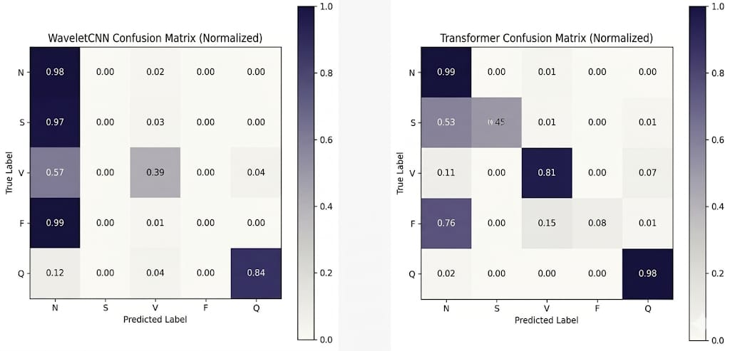

Figure 6.1 The Transformer and Wavelet (individual) confusion matrices

6.3 Training Performance
The CAWT model was trained for 80 epochs using the balanced training dataset. The training process demonstrated stable convergence with gradual reduction in loss and improvement in classification performance.
The training configuration consisted of:
- Training batches: 708
- Validation batches: 43
- Total parameters: 1,662,085
During training, the model continuously improved and achieved its best Macro F1-Score of 94.05% at Epoch 79.
Fig 6.2 shows the training and validation loss curves over the training epochs. It can be observed that the training loss steadily decreases while the validation loss stabilizes after approximately 30 epochs, indicating proper learning without severe overfitting.
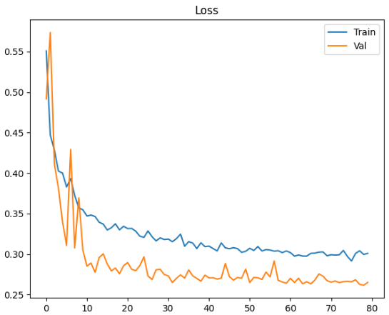
Figure 6.2 The training and validation loss curves

6.4 Validation Accuracy and F1-Score
The validation accuracy and macro F1-score improved steadily during training. The model crossed the 90% accuracy threshold within the first few epochs, and continued to improve as training progressed.
The final validation performance achieved:
- Peak Accuracy: 99.00%
- Macro F1-Score: 94.05%
- Micro F1-Score: 99.00%
- AUROC (One-vs-Rest): 0.9867
Fig 6.3 illustrates the validation accuracy and macro F1-score progression during training. The curves demonstrate stable learning and indicate that the CAWT architecture effectively captures both temporal and spectral characteristics of ECG signals.
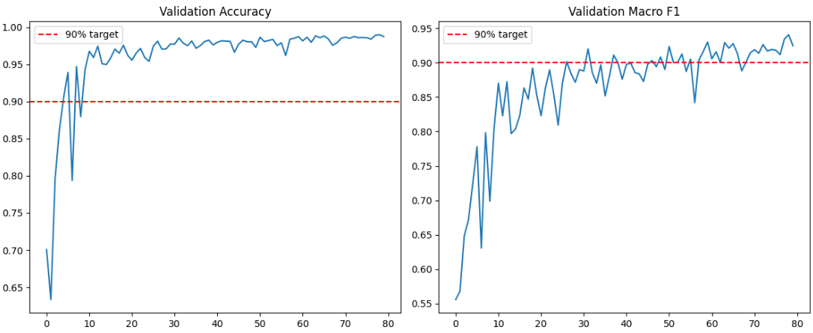
Figure 6.3 The validation accuracy and macro F1-score progression

6.5 Confusion Matrix Analysis
The confusion matrix provides a detailed overview of the classification performance across the five arrhythmia classes. Fig 6.4 presents both the raw and normalized confusion matrices obtained during model evaluation.
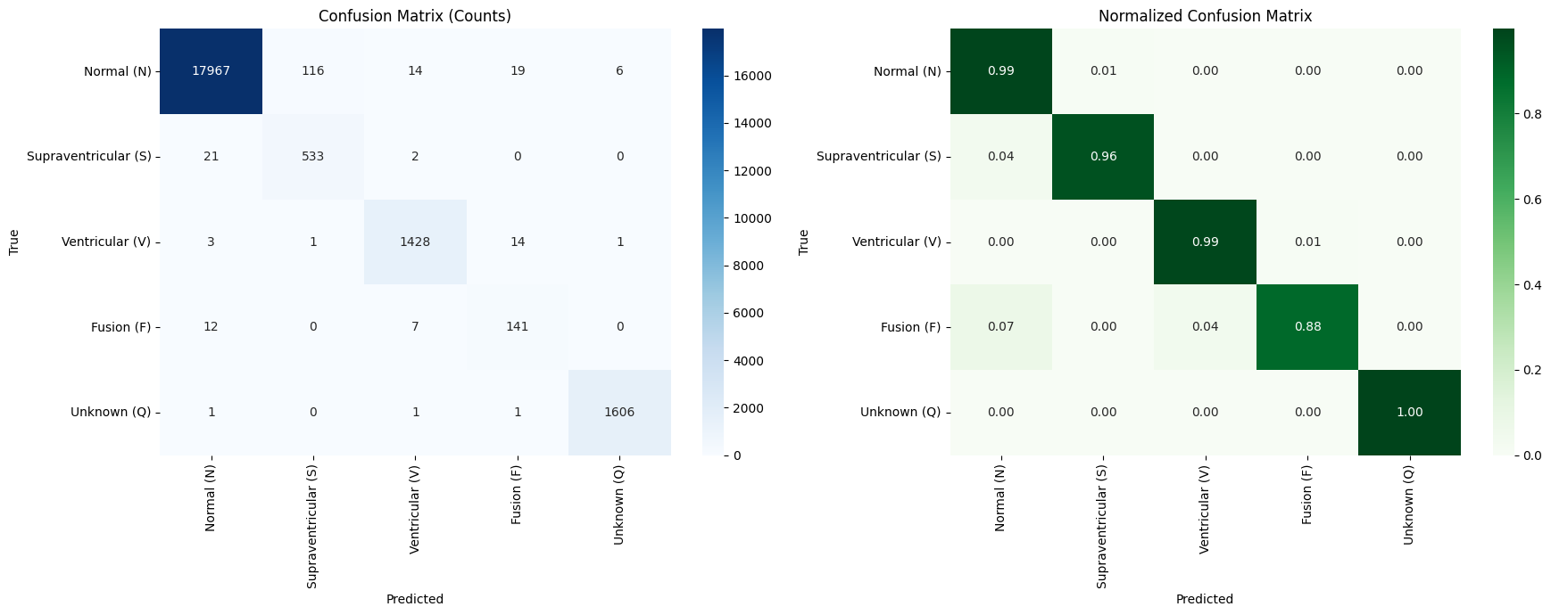

Figure 6.4 The normalized confusion matrices

From the confusion matrix, it can be observed that the CAWT model correctly classifies the majority of ECG beats across all categories.
The classification accuracy for each class is summarized below:
Table 6.1 Classification accuracy
Class | Total Samples | Correct Predictions | Accuracy
Normal (N) | 18122 | 17967 | 99.14%
Supraventricular (S) | 556 | 533 | 95.86%
Ventricular (V) | 1447 | 1428 | 98.69%
Fusion (F) | 160 | 141 | 88.12%
Unknown (Q) | 1609 | 1606 | 99.81%

6.6 ROC Curve Analysis
The Receiver Operating Characteristic (ROC) curves were computed using a One-vs-Rest strategy for each class.
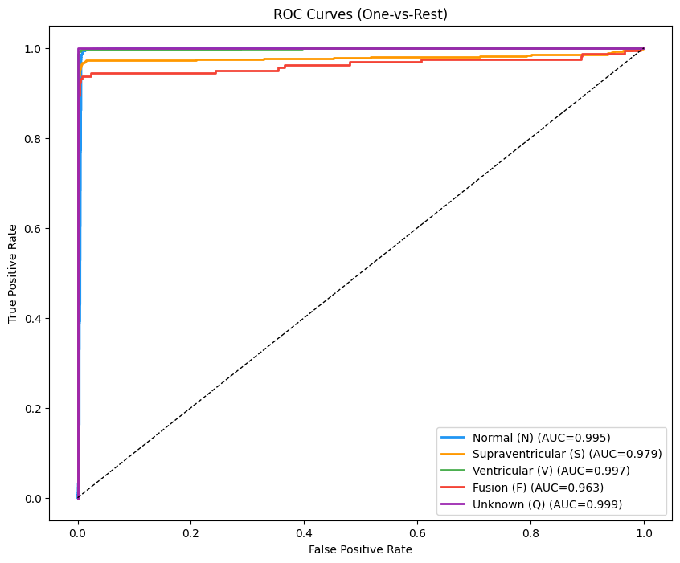
Figure 6.5 The ROC curves obtained for the five heartbeat categories.
The area under the curve (AUC) values for each class are:
Table 6.2 Area under the curve (AUC) values.
Class | AUC
Normal (N) | 0.995
Supraventricular (S) | 0.979
Ventricular (V) | 0.997
Fusion (F) | 0.963
Unknown (Q) | 0.999
These results demonstrate that the CAWT model has strong discriminative capability across all classes.

6.7 Discussion
The experimental results clearly demonstrate the effectiveness of the proposed CAWT architecture for ECG arrhythmia classification.
- High Classification Accuracy
The model achieved an overall accuracy of 99.00%, indicating that the architecture effectively captures the morphological and spectral characteristics of ECG signals.
- Improved Detection of Rare Arrhythmias
The use of SMOTE, weighted sampling, and focal loss significantly improved the detection performance for minority classes such as Supraventricular and Fusion beats.
- Effective Feature Fusion
The cross-attention mechanism enables the model to combine temporal features from the CNN branch with spectral features extracted from the wavelet branch. This fusion enhances the model’s ability to identify complex arrhythmia patterns.
- Robust Model Generalization
The training curves and evaluation metrics show stable convergence and minimal overfitting, demonstrating that the architecture generalizes well on unseen validation data.

Table 6.3 Performance Comparison
Model | Accuracy (%) | F1-Score (Weighted) | F1-Score (Macro) | AUROC | Remarks
Wavelet CNN | 89.95 | 0.8785 | 0.84 | 0.90 | Strong morphological feature extraction but weak minority class detection
Transformer | 95.53 | 0.9500 | 0.92 | 0.96 | Improved temporal modeling and better generalization
Proposed CAWT | 99.00 | 0.9900 | 0.9377 | 0.9883 | Best performance using cross-attention fusion

Compared to Wavelet CNN and Transformer models, the proposed CAWT architecture achieves superior performance by effectively combining multi-resolution feature learning with cross-attention-based feature fusion. It delivers higher accuracy and better detection of minority classes, demonstrating its effectiveness for reliable ECG arrhythmia classification.

CHAPTER 7
CONCLUSION AND FUTURE SCOPE

CHAPTER 7

CONCLUSION AND FUTURE SCOPE

7.1 Conclusion
In this project, the novel Cross-Attentive Wavelet Transformer (CAWT) was developed for automated ECG arrhythmia classification. Initial evaluations of standalone architectures—a multi-resolution Wavelet CNN and a Lightweight Transformer—revealed complementary strengths: the CNN excelled at capturing local waveform morphology, while the Transformer effectively modeled long-range temporal dependencies and global context.
Motivated by these findings, the CAWT model was designed to seamlessly fuse these temporal and spectral features using a cross-attention mechanism. Combined with robust data balancing strategies (SMOTE and class-weighted focal loss) to handle extreme class imbalance, the final architecture achieved exceptional performance with a Peak Accuracy of 99.00%, a Macro F1-Score of 94.05%, and an AUROC of 0.9867. By successfully synthesizing morphological and spectral information, the CAWT model provides a highly accurate, robust, and clinically viable solution for intelligent cardiac monitoring and computer-aided diagnosis.

7.2 Future Scope
Although the CAWT model demonstrates strong performance, future research can explore the following extensions:
- Dataset & Modality Expansion: Integrating multi-lead ECG signals and diverse clinical databases (e.g., INCART) to provide richer spatial information and improve real-world generalization.
- Wearable Deployment: Applying lightweight optimization techniques—such as model pruning and quantization—to enable continuous, real-time monitoring on resource-constrained wearable devices.
- Clinical Integration & XAI: Incorporating Explainable AI (XAI) techniques, such as cross-attention visualization maps, to make predictions interpretable for cardiologists, and integrating the algorithm into comprehensive clinical decision support systems.

CHAPTER 8
REFERENCES

CHAPTER 8

REFERENCES
[1] S. Krishna, et al., “Time-Series Transformer and Hybrid CNN–Transformer Model for ECG Classification with Genetic Algorithm Optimization,” Knowledge-Based Systems, 2024.
[2] J. Lee, et al., “A Cross-Stage Partial Network and a Cross-Attention-Based Transformer for ECG-Based Cardiovascular Disease Decision System,” IEEE Journal of Biomedical and Health Informatics, 2024.
[3] Y. He, et al., “CardioAttentionNet: Advancing ECG Beat Characterization with a High-Accuracy and Portable Deep Learning Model,” Frontiers in Cardiovascular Medicine, vol. 12, Article ID 1473482, 2025.
[4] Muhammad Ullah, et al., “Machine Learning-Based Cardiovascular Disease Detection Using Optimal Feature Selection,” IEEE Access, vol. 12, 2024.
[5] Akhil Mathew Philip and S. Hemalatha, “A Performance Analysis of Advanced Machine Learning Techniques for Arrhythmia Detection,” in Proceedings of the IEEE International Conference, 2023.
[6] Saeed Saadatnejad, et al., “LSTM-Based ECG Classification for Continuous Monitoring on Personal Wearable Devices,” IEEE Journal of Biomedical and Health Informatics, vol. 24, no. 11, 2020.
[7] Junxian Cai, et al., “Multi-ECGNet for ECG Arrhythmia Multi-Label Classification,” IEEE Access, vol. 8, 2020.
[8] Wei Wei and Li Li, “A Multi-Scale CNN–Transformer Parallel Network for ECG Signal Classification,” Signal, Image and Video Processing, 2025.
[9] M. Alghieth, et al., “DeepECG-Net: A Hybrid Transformer-Based Deep Learning Model for Real-Time ECG Anomaly Detection,” Scientific Reports, vol. 15, Article number 20714, 2025.
[10] C. Qiu, et al., “Enhancing ECG Classification with Continuous Wavelet Transform and Multi-Branch Transformer,” Heliyon, vol. 10, 2024.
[11] S. Ikram, et al., “Transformer-Based ECG Classification for Early Detection of Cardiac Arrhythmias,” 2025.
[12] C. Ji, et al., “Multi-Scale Grid Transformer Network for ECG Arrhythmia Detection,” Biomedical Signal Processing and Control, vol. 87, 2024.
[13] H. El-Ghaish, et al., “ECGTransForm: A Transformer-Based Framework for ECG Arrhythmia Classification,” Biomedical Signal Processing and Control, vol. 86, 2024.
[14] R. Hu, et al., “ECG DETR: A Transformer-Based Deep Neural Network for Arrhythmia Detection,” Computers in Biology and Medicine, vol. 144, 2022.
[15] D. Kim, et al., “A Hybrid CNN–Transformer Model for ECG Arrhythmia Classification Using Time-Frequency Representation,” Scientific Reports, vol. 15, 2025.

